Guidelines for Book Clubs/ Psych in Lit

You have been selected to participate in a Book Club often called a “lit circle.” Instead of me directing your every move throughout a book, you will step into that role and become the director. You will be grouped with 4-5 of your classmates. This creates your “Book Club.” You each will have a role to fulfill and be responsible for both your own learning and your group’s progress.
Each week, you will be expected to:
1. Participate in all group discussions.
2. Read outside of class.
3. Take on a role and be responsible for that role.
4. Complete all assignments ON TIME!
5. Be respectful of rules, peers, and other groups.
6. Have integrity, be honest and communicative.
Name of Book Club:

_______________________________________

Book Title:

_______________________________________

Role options:  Choose a different role weekly | Description:
- Discussion Director  (EVERY WEEK SOMEONE MUST ROTATE TO BE THIS PERSON) | - Write down at least five questions (not “yes/no” questions) for the group to discuss during each meeting. They must be level 3 or 4 (use the chart). Write questions that are controversial or require students to think about what they would do in a situation that relate to the story are good conversation starters.  - DO NOT WRITE CLOSED QUESTIONS- OR QUESTIONS THAT ARE BASIC FACTS ABOUT THE BOOK AND CAN BE ANSWERED IN A FEW WORDS OR WITH A SIMPLE YES OR NO. Use the question matrix to help with developing questions if needed.  - While the discussion is taking place you will take notes on each individual group member’s response. You also must write a 4 or more-sentence paragraph-response to each of your questions before the discussion to share with your book club after group members have a chance to answer.  - You will also be responsible for organizing the work and turning it in as well as communicating any issue with the teacher.  - During the discussion, your job is to encourage all group members to participate by involving them in the discussion and to ask follow-up questions when conversation lags.  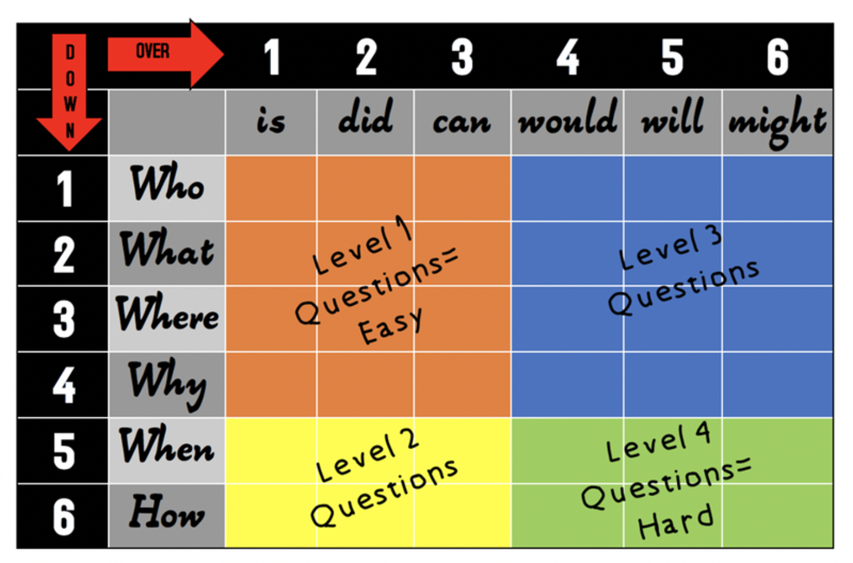
- Character Captain & Illustrator | - Find a digital picture that represents one of your characters and write a paragraph (5 sentences) explaining how the picture showcases your character.  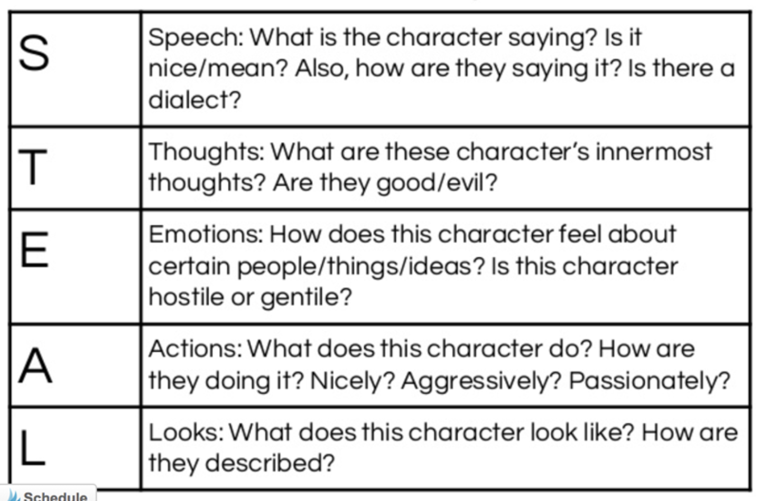  - This student will be responsible for logging the 5 methods of characterization (STEAL- see STEAL supports) for the novels’ main characters and finding 1 supporting quotation to accompany each portion of STEAL. Then, explain what each quote REVEALS about your character (you should have an analysis for each portion of STEAL)  - During the meeting, show your group the character image and your explanation. Share your STEAL quotes. Ask your group to discuss how they believe the quotes relate to the character. Then, read your explanations.
- Real World Advocate Researcher  G | - Find at least two connections between the story and the world through research and/or current events. These connections might relate to current or historical events, movies, art, poetry, music, other books. You are not using personal connections for this task.  - Write a paragraph explanation of each connection with specific details and share the source you found the information from with your group. Document sources with MLA and turn in both the written response and sources for the week.  - Cite 3 DIRECT quotations from your connection research that you think are significant. Write a 4 or more-sentence explanation of why that quote is significant. Try to make connections to other events in the novel.  - During the meeting, explain your connection and quotes. Ask your group what they notice about the quote, what they think it means, and what role the quote plays in the story.  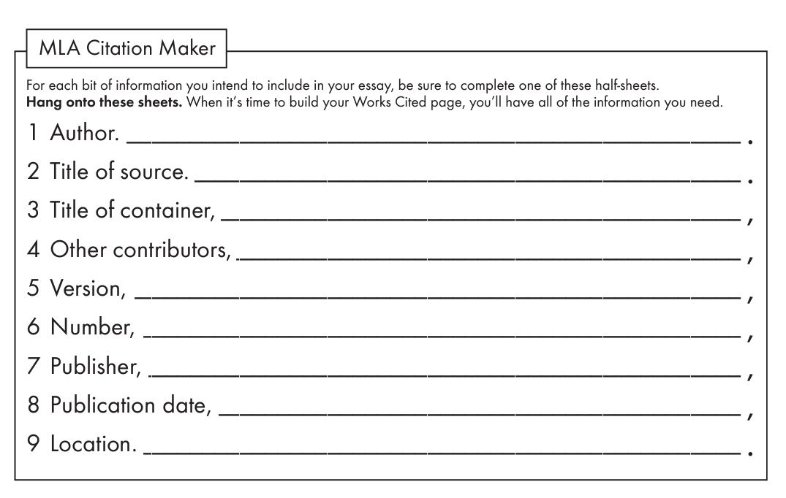

Role options: | Description:
- Summarizer Secretary and Stylistic Analysis | PART 1:  - For each chapter of the selected reading, create a title (not the one given)- write 2 sentences explaining why you named each chapter the title that you did.  - During the meeting, read each title and have your group discuss why you chose the title. After you have discussed, read your explanations.  PART 2:  - Pick two strong stylistic sentences from your novel. Write the quotes. Then, dissect both of your two quotes and explain what qualities make each sentence strong in 4 or more paragraphs.  How to evaluate style help resource.  - During discussion, lead group members to discuss and determine which of your two quotes is stronger stylistically.
- Plot Analysis Signpost Signaler  (only complete this task one time) | - Analyze the plotline by looking at signposts from Note and Notice. You are responsible for finding each of the signposts in the text and analyzing them using the attached Signpost worksheet. Try to make the signposts from the pages that were directly read for the given week. You should not have the same responses as any of your group members, or you will not be rewarded points for the week. Please make sure to include direct textual evidence QUOTES for this task.  - During the discussion, pick two of your signposts to discuss with the group. Ask your group, what they feel the signpost reveals. Then, explain your analysis.

Weekly Journal Ideas-
Once we finish each book club meeting, will spend time on journal writing with our books. A journal should be 3-4 paragraphs (4 or more sentences per paragraph, blending simple and complex sentences), on the supplied weekly topics. Overall, you should use your discussion during book club to guide your journal responses.

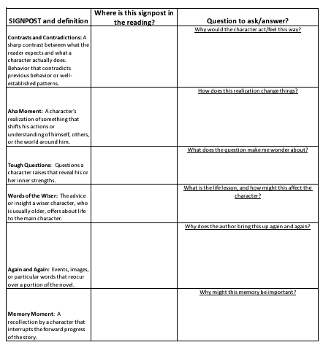

Book Plan- Please fill in the charts below to be sure that your book is completed on time. You need to stick to your reading schedule. Your calendar will provide class meeting times. How you divide the pages is up to you but divide wisely! YOU WILL FILL OUT YOUR ROLE WEEKLY AND TURN THIS PAPER IN AT THE END OF THE UNIT- MAKE SURE YOU ARE COMPLETING A DIFFERENT TASK EACH WEEK.

Date: | Start | End |  | Date: | Start | End
Week 1 |  |  |  | Week 4
 | Discussion Director: |  |  |  | Discussion Director:
YOUR ROLE THIS WEEK: |  |  |  | YOUR ROLE THIS WEEK:
Week 2 |  |  |  | Week 5
 | Discussion Director: |  |  |  | Discussion Director:
YOUR ROLE THIS WEEK: |  |  |  | YOUR ROLE THIS WEEK:
Week 3 |  |  |  | Week 6
 | Discussion Director: |  |  |  | Discussion Director:
YOUR ROLE THIS WEEK: |  |  |  | YOUR ROLE THIS WEEK:

Weekly Check-out Log
One of these forms must be completed at the end of each class meeting with your Book Club.

Date | Absent Members | What was accomplished?
Who was unprepared this time: | What pages will we read for the next book club? | NEXT ROLES & DUE DATE

Group Evaluations
 | YES | NO | WHY?
Everyone participated and shared in the discussion process. Communication is interactive.

The group is supportive of its individual members. Group climate is friendly and welcoming.

Group members often ask questions for clarification or elaboration.

The group discussion stays on topic or on directly related issues.

The group is energetic or ecstatic.

- What was the best thing about the way this group worked together?

- What was one problem the group had? How did the group solve that problem?

- Was each role prepared? Who was not and why?

WEEKLY BOOK CLUB MEETING CHECKLIST:

- Each person in your group will go through their individual assignment roles (as a group you will discuss their contributions for the week).

- Write down which role each group member (1st and last name) had and staple all sheets together for the week (unless completed on Teams). Make sure the title for each role is on the stapled pages. Ex: Discussion Director will write “Discussion Director” on top of his/her page with 5 questions and responses for the week.

- Complete the check-out log, group evaluation sheet, and check off list.

- Review what the reading expectations are for the upcoming week.

- Write your individual journal entry after the weekly book club is finished (keep these in your journal labeled as week 1, week 2, etc...).

Discussion Director ________________________________________
Character Captain. _________________________________________
Real World Advocate _______________________________________
________________________________________
Summarizer/Stylistic Secretary___________________________________
Signpost Signaler ____________________________________________

